**WE Assignment 1**

1. **Homepage (index.html):**

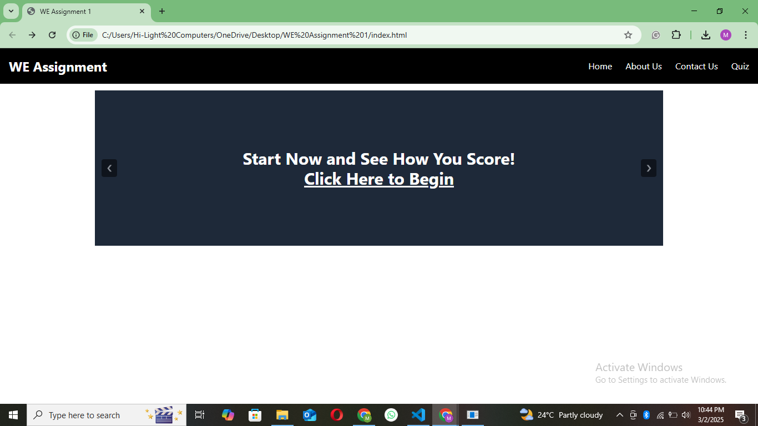

**HTML Code:**

<!DOCTYPE html>

<html lang="en">

<head>

    <meta charset="UTF-8">

    <meta name="viewport" content="width=device-width, initial-scale=1.0">

    <title>22K-5186 WE Assignment 1</title>

    <script src="https://unpkg.com/@tailwindcss/browser@4"></script>

</head>

<body class="bg-white">

    <div class="bg-black text-white p-4 flex justify-between items-center">

        <div class="text-2xl font-bold">WE Assignment</div>

        <ul class="flex space-x-6">

            <li><a href="C:\Users\Hi-Light Computers\OneDrive\Desktop\WE Assignment 1\index.html" class="hover:underline">Home</a></li>

            <li><a href="C:\Users\Hi-Light Computers\OneDrive\Desktop\WE Assignment 1\about us\aboutUs.html" class="hover:underline">About Us</a></li>

            <li><a href="C:\Users\Hi-Light Computers\OneDrive\Desktop\WE Assignment 1\contact us\contactUs.html" class="hover:underline">Contact Us</a></li>

            <li><a href="C:\Users\Hi-Light Computers\OneDrive\Desktop\WE Assignment 1\quiz\quiz.html" class="hover:underline">Quiz</a></li>

        </ul>

    </div>

    <div class="relative w-full max-w-5xl mx-auto my-3">

        <div class="overflow-hidden relative flex flex-row justify-center content-center items-center bg-gray-800 text-white text-3xl font-bold  h-70">

            <div id="slides">

                <div id="slide">

                    <div>

                        Welcome to the Ultimate Quiz Challenge

                    </div>

                </div>

                <div id="slide">

                    <div>&rarr; Select your own quiz</div>

                    <div class="my-3">&rarr; Answer each question within 20 seconds</div>

                    <div>&rarr; Test your knowledge</div>

                </div>

                <div id="slide" class="text-center">

                    <div>Start Now and See How You Score!</div>

                    <div>

                        <u><a href="./quiz/quiz.html">Click Here to Begin</a></u>

                    </div>

                </div>

            </div>

        </div>

        <div class="absolute top-1/2 left-0 transform -translate-y-1/2">

            <button onclick="prevSlide()" class="bg-black text-white rounded mx-3 opacity-50 hover:opacity-100 min-w-7 min-h-8">

                &#10094;

            </button>

        </div>

        <div class="absolute top-1/2 right-0 transform -translate-y-1/2">

            <button onclick="nextSlide()" class="bg-black text-white rounded mx-3 opacity-50 hover:opacity-100 min-w-7 min-h-8">

                &#10095;

            </button>

        </div>

    </div>

    <script src="./app.js"></script>

</body>

</html>

**JS Code:**

let slideIndex = 0;

const slides = document.querySelectorAll('#slide');

function showSlide(index) {

    slides.forEach((slide, i) => {

        slide.style.display = (i === index) ? 'block' : 'none';

    });

}

function nextSlide() {

    slideIndex = (slideIndex + 1) % slides.length;

    showSlide(slideIndex);

}

function prevSlide() {

    slideIndex = (slideIndex - 1 + slides.length) % slides.length;

    showSlide(slideIndex);

}

function autoSlide() {

    nextSlide();

    setTimeout(autoSlide, 3000);

}

document.addEventListener('DOMContentLoaded', () => {

    showSlide(slideIndex);

    setTimeout(autoSlide, 3000);

});

1. **About us:**

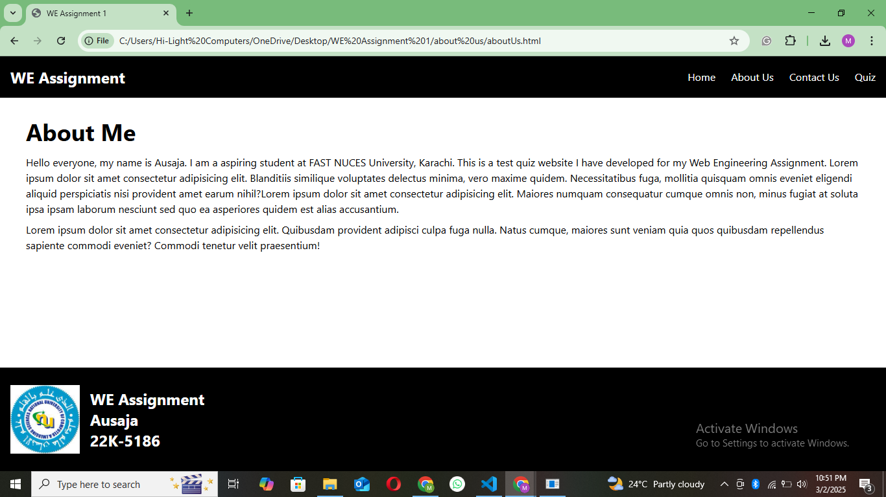

**HTML Code:**

<!DOCTYPE html>

<html lang="en">

<head>

    <meta charset="UTF-8">

    <meta name="viewport" content="width=device-width, initial-scale=1.0">

    <title>22K-5186 WE Assignment 1</title>

    <script src="https://unpkg.com/@tailwindcss/browser@4"></script>

</head>

<body class="bg-white">

    <div class="bg-black text-white p-4 flex justify-between items-center">

        <div class="text-2xl font-bold">WE Assignment</div>

        <ul class="flex space-x-6">

            <li><a href="C:\Users\Hi-Light Computers\OneDrive\Desktop\WE Assignment 1\index.html" class="hover:underline">Home</a></li>

            <li><a href="C:\Users\Hi-Light Computers\OneDrive\Desktop\WE Assignment 1\about us\aboutUs.html" class="hover:underline">About Us</a></li>

            <li><a href="C:\Users\Hi-Light Computers\OneDrive\Desktop\WE Assignment 1\contact us\contactUs.html" class="hover:underline">Contact Us</a></li>

            <li><a href="C:\Users\Hi-Light Computers\OneDrive\Desktop\WE Assignment 1\quiz\quiz.html" class="hover:underline">Quiz</a></li>

        </ul>

    </div>

    <div class="mx-10 py-4 h-full">

        <div class="text-4xl font-bold my-4">About Me</div>

        <div class="text-md">Hello everyone, my name is Ausaja. I am a aspiring student at FAST NUCES University, Karachi. This is a test quiz website I have developed for my Web Engineering Assignment. Lorem ipsum dolor sit amet consectetur adipisicing elit. Blanditiis similique voluptates delectus minima, vero maxime quidem. Necessitatibus fuga, mollitia quisquam omnis eveniet eligendi aliquid perspiciatis nisi provident amet earum nihil?Lorem ipsum dolor sit amet consectetur adipisicing elit. Maiores numquam consequatur cumque omnis non, minus fugiat at soluta ipsa ipsam laborum nesciunt sed quo ea asperiores quidem est alias accusantium.</div>

        <div class="mt-2">Lorem ipsum dolor sit amet consectetur adipisicing elit. Quibusdam provident adipisci culpa fuga nulla. Natus cumque, maiores sunt veniam quia quos quibusdam repellendus sapiente commodi eveniet? Commodi tenetur velit praesentium!</div>

    </div>

    <div class="absolute left-0 bottom-0 bg-black text-white text-2xl font-bold flex flex-wrap flex-row justify-start items-center w-full h-40">

        <div class="ml-4 h-4/6">

            <img src="./images/FAST Logo.jpg" alt="" class=" h-full">

        </div>

        <div class="mx-4">

            <div>WE Assignment</div>

            <div>Ausaja</div>

            <div>22K-5186</div>

        </div>

    </div>

</body>

</html>

1. **Contact us:**

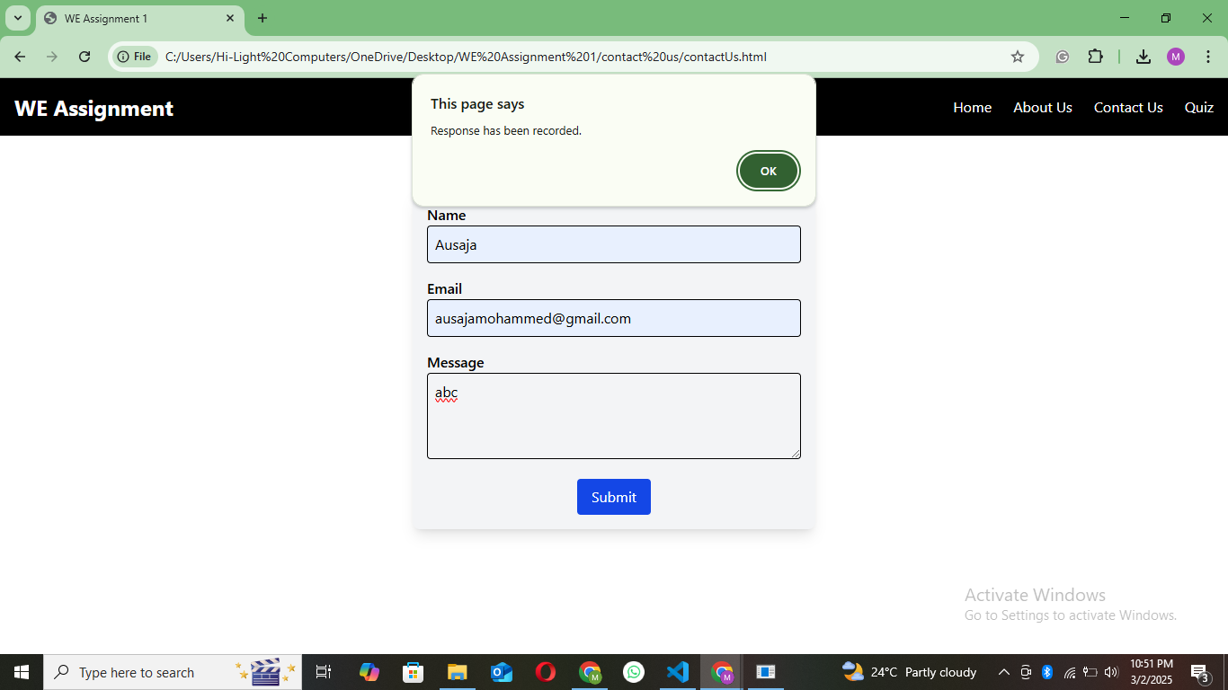

**HTML Code:**

<!DOCTYPE html>

<html lang="en">

<head>

    <meta charset="UTF-8">

    <meta name="viewport" content="width=device-width, initial-scale=1.0">

    <title>22K-5186 WE Assignment 1</title>

    <script src="https://unpkg.com/@tailwindcss/browser@4"></script>

</head>

<body class="bg-white">

    <div class="bg-black text-white p-4 flex justify-between items-center">

        <div class="text-2xl font-bold">WE Assignment</div>

        <ul class="flex space-x-6">

            <li><a href="C:\Users\Hi-Light Computers\OneDrive\Desktop\WE Assignment 1\index.html" class="hover:underline">Home</a></li>

            <li><a href="C:\Users\Hi-Light Computers\OneDrive\Desktop\WE Assignment 1\about us\aboutUs.html" class="hover:underline">About Us</a></li>

            <li><a href="C:\Users\Hi-Light Computers\OneDrive\Desktop\WE Assignment 1\contact us\contactUs.html" class="hover:underline">Contact Us</a></li>

            <li><a href="C:\Users\Hi-Light Computers\OneDrive\Desktop\WE Assignment 1\quiz\quiz.html" class="hover:underline">Quiz</a></li>

        </ul>

    </div>

    <div class="mt-15 p-4 max-w-md mx-auto bg-gray-100 rounded-lg shadow-lg flex flex-col justify-center items-center">

        <div class="mb-4 w-full">

            <label for="name" class="block font-semibold">Name</label>

            <input type="text" id="name" class="w-full p-2 border rounded">

        </div>

        <div class="mb-4 w-full">

            <label for="email" class="block font-semibold">Email</label>

            <input type="email" id="email" class="w-full p-2 border rounded">

        </div>

        <div class="mb-4 w-full">

            <label for="message" class="block font-semibold">Message</label>

            <textarea id="message" class="w-full p-2 border rounded h-24"></textarea>

        </div>

        <div>

            <button id="submitBtn" onclick="recordResponse()"

                class="bg-blue-500 text-white px-4 py-2 rounded hover:bg-blue-700">

                Submit

            </button>

        </div>

    </div>

    <script src="C:\Users\Hi-Light Computers\OneDrive\Desktop\WE Assignment 1\contact us\app.js"></script>

</body>

</html>

**JS Code:**

function recordResponse(){

    let name = document.querySelector("#name").value;

    let email = document.querySelector("#email").value;

    let message = document.querySelector("#message").value;

    if(name == "" || email == "" || message == ""){

        alert("Fill all the necessary fields.");

    }

    else{

        alert("Response has been recorded.")

        document.querySelector("#name").value = "";

        document.querySelector("#email").value = "";

        document.querySelector("#message").value = "";

    }

}

1. **Quiz:**

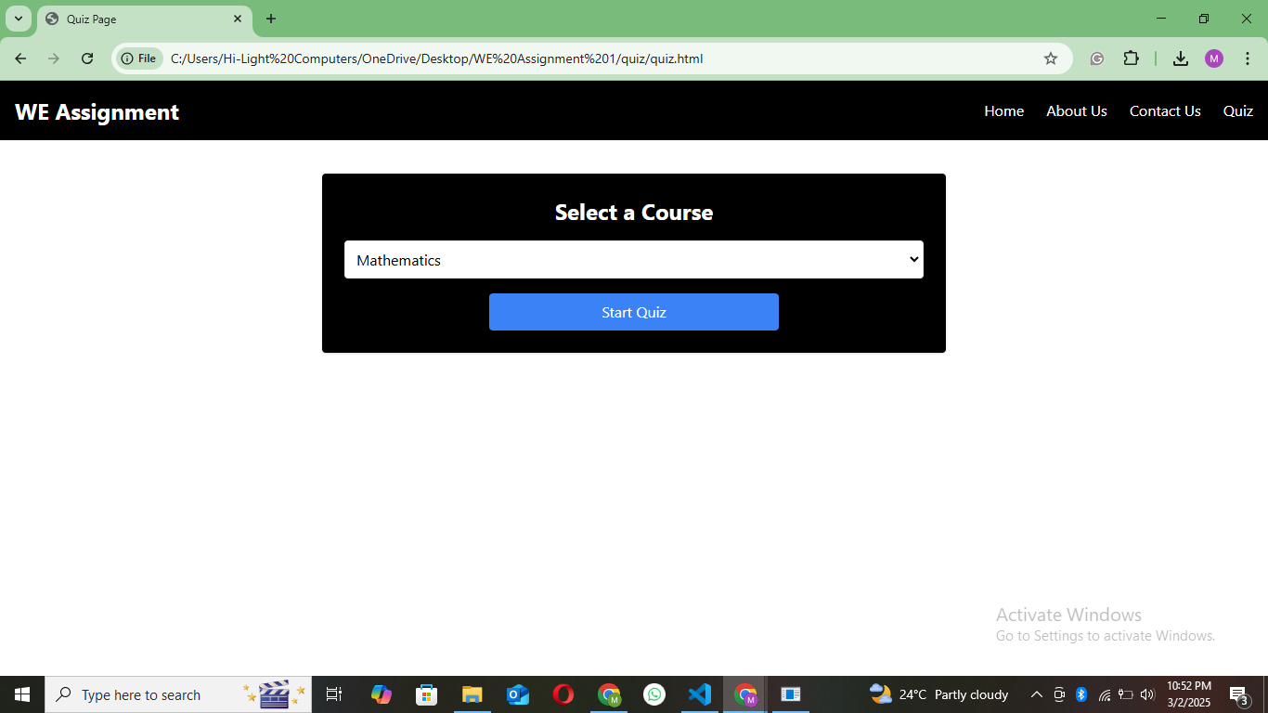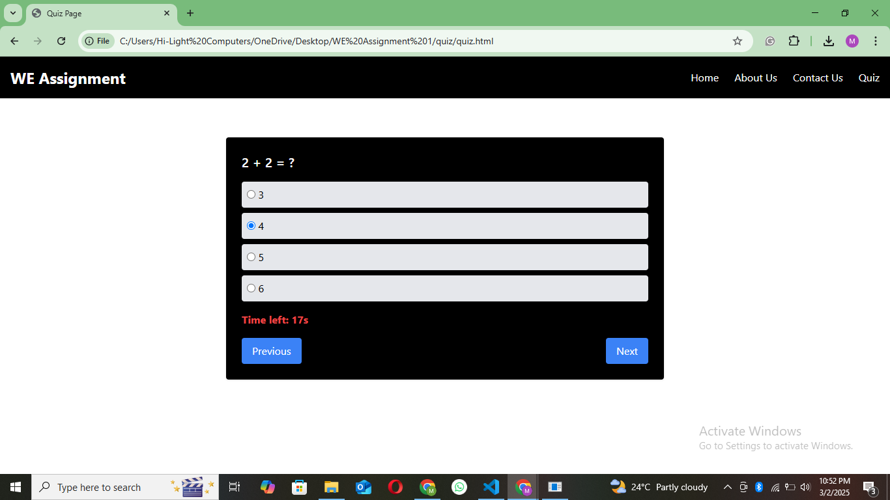

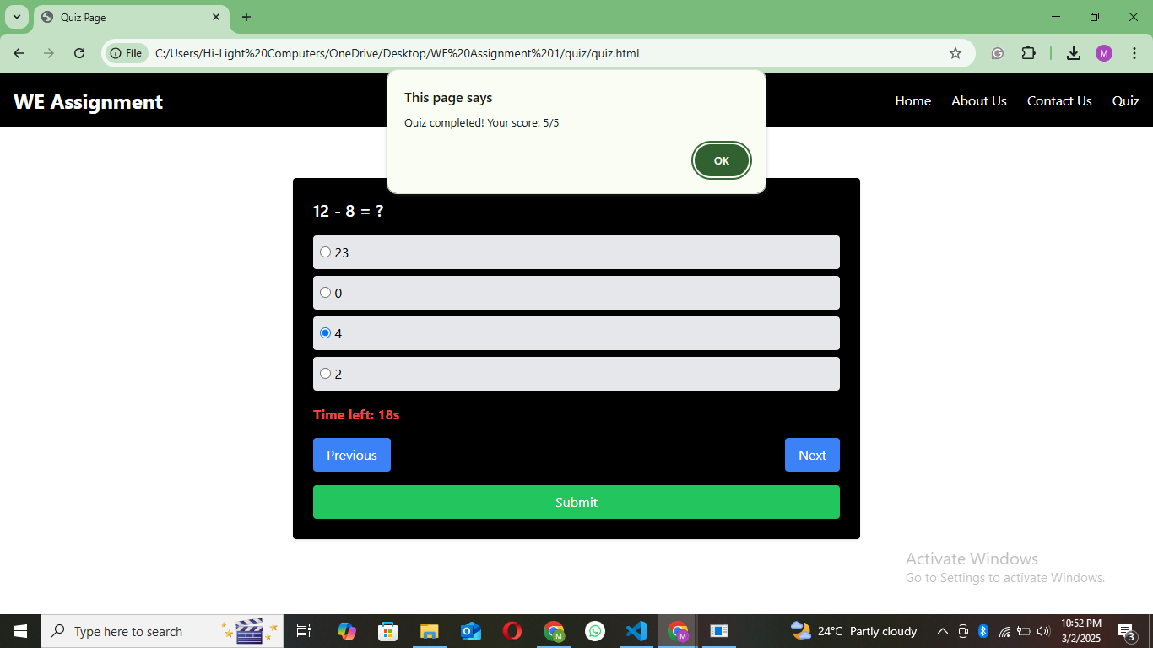

**HTML Code:**

<!DOCTYPE html>

<html lang="en">

<head>

    <meta charset="UTF-8">

    <meta name="viewport" content="width=device-width, initial-scale=1.0">

    <title>22K-5186 WE Assignment 1</title>

    <script src="https://cdn.tailwindcss.com"></script>

</head>

<body class="bg-white">

    <div class="bg-black text-white p-4 flex justify-between items-center">

        <div class="text-2xl font-bold">WE Assignment</div>

        <ul class="flex space-x-6">

            <li><a href="C:\Users\Hi-Light Computers\OneDrive\Desktop\WE Assignment 1\index.html" class="hover:underline">Home</a></li>

            <li><a href="C:\Users\Hi-Light Computers\OneDrive\Desktop\WE Assignment 1\about us\aboutUs.html" class="hover:underline">About Us</a></li>

            <li><a href="C:\Users\Hi-Light Computers\OneDrive\Desktop\WE Assignment 1\contact us\contactUs.html" class="hover:underline">Contact Us</a></li>

            <li><a href="C:\Users\Hi-Light Computers\OneDrive\Desktop\WE Assignment 1\quiz\quiz.html" class="hover:underline">Quiz</a></li>

        </ul>

    </div>

    <div class="m-5 p-4">

        <div id="courseSelectContainer" class="max-w-2xl mx-auto bg-black text-white p-6 rounded shadow flex flex-col justify-center items-center">

            <h1 class="text-2xl font-bold text-center mb-4">Select a Course</h1>

            <select id="courseSelect" class="text-black w-full p-2 border rounded mb-4">

                <option value="math">Mathematics</option>

                <option value="science">Science</option>

                <option value="history">History</option>

            </select>

            <button onclick="startQuiz()" class="bg-blue-500 text-white px-4 py-2 rounded w-1/2">Start Quiz</button>

        </div>

        <div id="quizContainer" class="max-w-2xl mx-auto bg-black text-white p-6 rounded shadow mt-6 hidden">

            <h2 id="question" class="text-xl font-semibold mb-4"></h2>

            <div id="optionsContainer" class="space-y-2"></div>

            <p id="timer" class="text-red-500 font-bold mt-4"></p>

            <div class="flex justify-between mt-4">

                <button onclick="prevQuestion()" class="bg-blue-500 text-white px-4 py-2 rounded">Previous</button>

                <button onclick="nextQuestion()" class="bg-blue-500 text-white px-4 py-2 rounded">Next</button>

            </div>

            <button onclick="submitQuiz()" id="submitBtn" class="bg-green-500 text-white px-4 py-2 rounded w-full mt-4 hidden">Submit</button>

        </div>

    </div>

    <script src="C:\Users\Hi-Light Computers\OneDrive\Desktop\WE Assignment 1\quiz\app.js"></script>

</body>

</html>

**JS Code:**

let quiz = [], currentQuestion = 0, timer;

function startQuiz() {

    const course = document.querySelector("#courseSelect").value.toLowerCase();

    if (course === "math") {

        quiz = [

            { question: "2 + 2 = ?", options: ["3", "4", "5", "6"], answer: "4", selected: "" },

            { question: "5 * 6 = ?", options: ["30", "25", "40"], answer: "30", selected: "" },

            { question: "Square root of 49?", options: ["7", "8", "9", "10"], answer: "7", selected: "" },

            { question: "10 / 2 = ?", options: ["1", "3", "5", "7"], answer: "5", selected: "" },

            { question: "12 - 8 = ?", options: ["23", "0", "4", "2"], answer: "4", selected: "" }

        ];

    } else if (course === "science") {

        quiz = [

            { question: "Water's chemical formula?", options: ["H2O", "CO2", "O2", "NO2"], answer: "H2O", selected: "" },

            { question: "Sun is a?", options: ["Planet", "Star", "Comet"], answer: "Star", selected: "" },

            { question: "Human body temperature?", options: ["37°C", "40°C", "35°C"], answer: "37°C", selected: "" },

            { question: "Gas we breathe in?", options: ["Oxygen", "Nitrogen", "Carbon dioxide"], answer: "Oxygen", selected: "" },

            { question: "Earth orbits?", options: ["Moon", "Sun", "Mars"], answer: "Sun", selected: "" }

        ];

    } else {

        quiz = [

            { question: "Who discovered America?", options: ["Columbus", "Newton", "Einstein"], answer: "Columbus", selected: "" },

            { question: "WWII ended in?", options: ["1945", "1939", "1950"], answer: "1945", selected: "" },

            { question: "Great Wall of China built by?", options: ["Qin Dynasty", "Ming Dynasty", "Tang Dynasty"], answer: "Qin Dynasty", selected: "" },

            { question: "First US President?", options: ["Lincoln", "Washington", "Jefferson"], answer: "Washington", selected: "" },

            { question: "French Revolution started in?", options: ["1789", "1804", "1765"], answer: "1789", selected: "" }

        ];

    }

    document.querySelector("#courseSelectContainer").classList.add("hidden");

    document.querySelector("#quizContainer").classList.remove("hidden");

    loadQuestion();

}

function loadQuestion() {

    clearInterval(timer);

    if (currentQuestion >= quiz.length) {

        document.querySelector("#submitBtn").classList.remove("hidden");

        return;

    }

    if(quiz[currentQuestion].selected == ""){

        document.querySelector("#question").innerText = quiz[currentQuestion].question;

        let optionsHTML = "";

        for (let i = 0; i < quiz[currentQuestion].options.length; i++) {

            optionsHTML += `

                <label class="block bg-gray-200 text-black hover:bg-blue-500 p-2 rounded cursor-pointer">

                    <input id="option${i}" type="radio" name="answer" value="${quiz[currentQuestion].options[i]}">

                    ${quiz[currentQuestion].options[i]}

                </label>`;

        }

        document.querySelector("#optionsContainer").innerHTML = optionsHTML;

        let timeLeft = 20;

        document.querySelector("#timer").innerText = `Time left: ${timeLeft}s`;

        timer = setInterval(() => {

            timeLeft--;

            document.querySelector("#timer").innerText = `Time left: ${timeLeft}s`;

            if (timeLeft === 0) {

                clearInterval(timer);

                saveAnswer();

                nextQuestion();

            }

        }, 1000);

    }

}

function saveAnswer(){

    let options = document.getElementsByName("answer");

    for (let i = 0; i < options.length; i++) {

        if (options[i].checked) {

            quiz[currentQuestion].selected = options[i].value;

            return;

        }

    }

    quiz[currentQuestion].selected = "N/A";

}

function nextQuestion() {

    saveAnswer();

    currentQuestion++;

    loadQuestion();

}

function prevQuestion() {

    if (currentQuestion > 0) currentQuestion--, loadQuestion();

}

function submitQuiz() {

    let score = 0;

    for (let i = 0; i < quiz.length; i++)

        if (quiz[i].selected == quiz[i].answer) score++;

    alert(`Quiz completed! Your score: ${score}/${quiz.length}`);

}